Documentation of American Debt

a) Home Page Matter

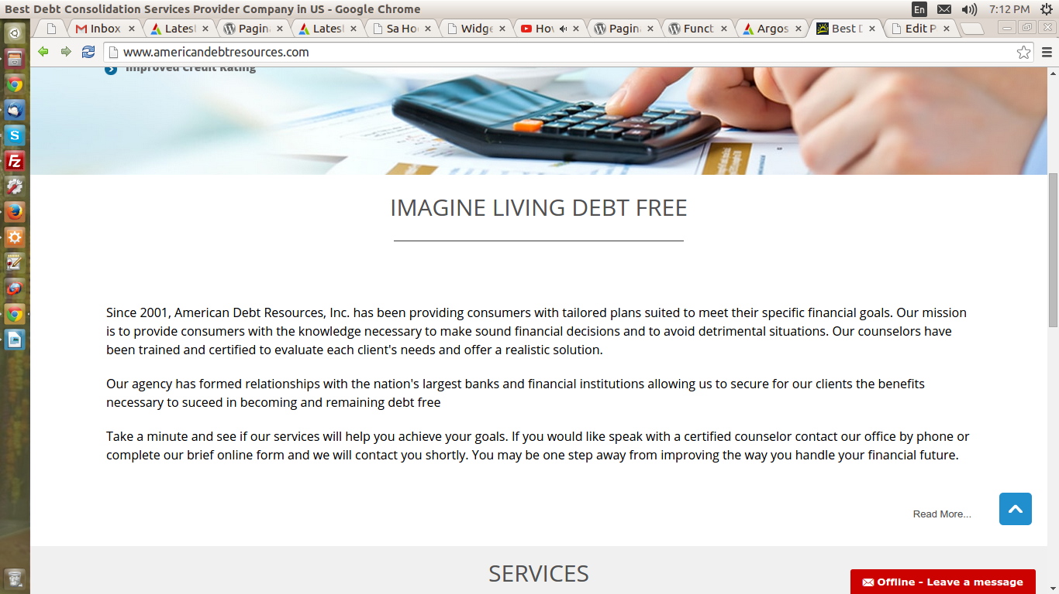
Login to the admin panel of the wordpress.
Click on Pages ->All Pages then search the title name Imagine Living debt Free you will find there and click on edit, you will find the matter which is shown here is come from the page having the title Imaging Living Debt Free. You can change the content here for the home page.

b) Service on the Home Page.
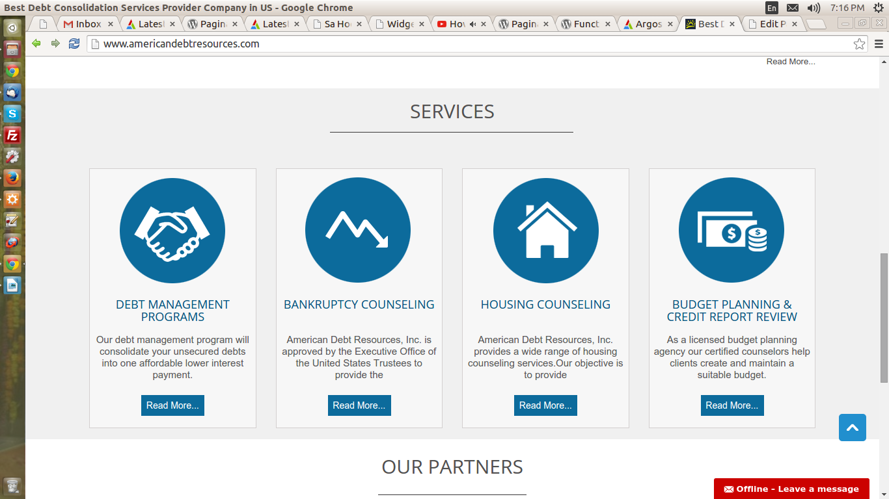
For the Service on the Home page click on the Post link under this click on categories you will find the page like this. As shown below.
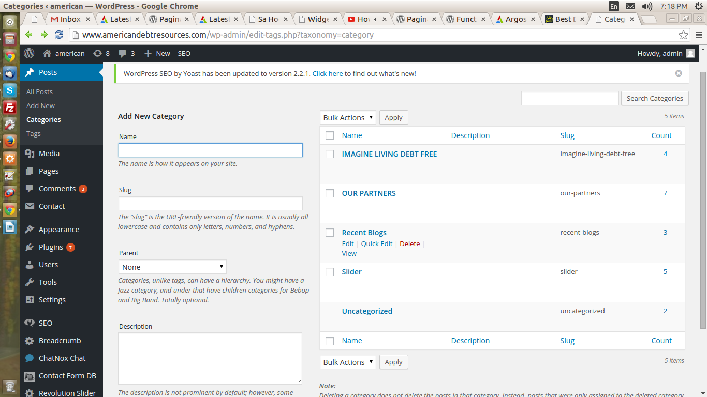
Click on the title named Imagine Living debt Free and click on it you will find the list of categories of service which is display on the home page. After clicking on the link showing the arrow the page appear like this as shown below.
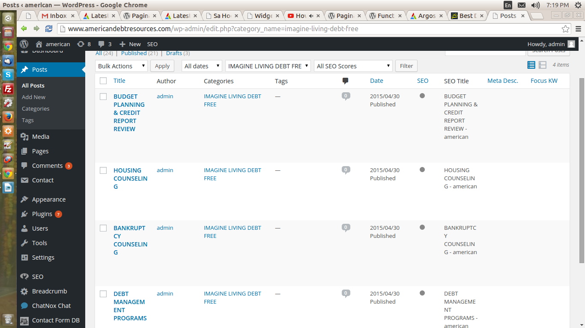
The arrow pointer point to the list of category which is display on the home page under the service categories. To add or edit the content we take a category Budget Planning & Credit report Review .
Click on it which show the page is looking like this.
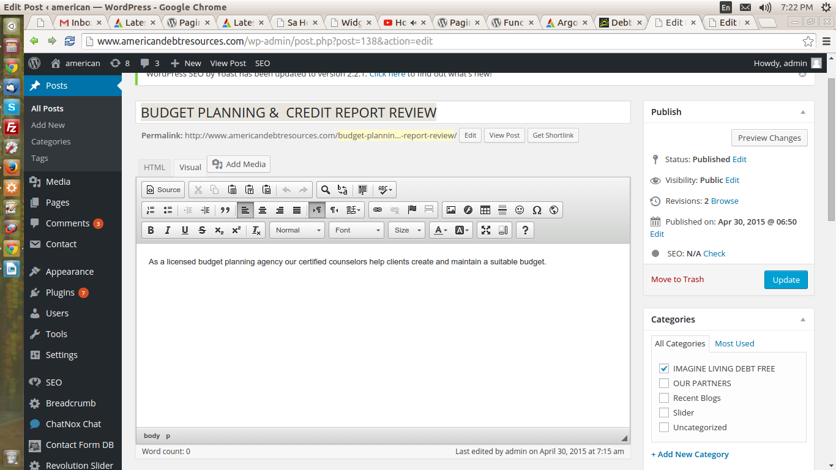
The arrow point to the textarea where the data is updated the data is visible under the category image also known as small desc. Here you will change the text which is visible on the home page under the category image.
To add or edit the page for read more details click on the page and find the page with the category title such as for we find say Budget Planning and Credit Report Review. The page look like this.
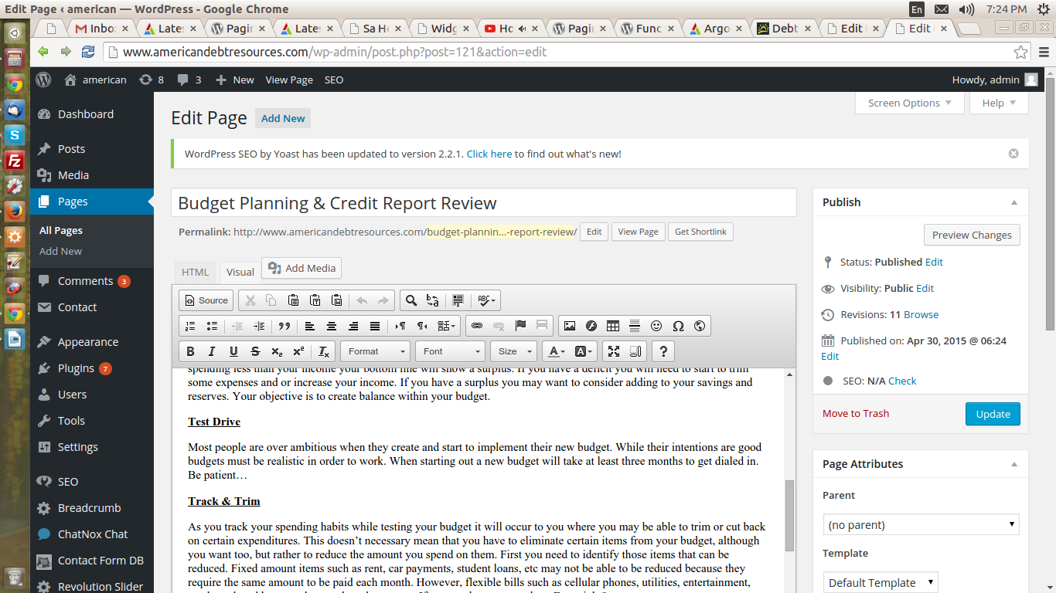
This is the content which is appear on the Read More page if you want to change this you can change the content of readmore for the page section.

